Used Oil Analysis Data from Wind Turbine Gear Reducers Helps Define Achievable Oil Drain Intervals

Rick Russo, Kevin Harrington, Sandra Legay,
ExxonMobil Fuels, Lubricants & Specialties Marketing

Wind turbines are sophisticated machines, operating in demanding environments. As such, it is very important to select the right lubricant, as the proper oil choice can improve wind turbine availability. This article focuses on the challenges in wind turbine lubrication, specifically addressing the use of advanced synthetic gear oil, Mobilgear SHC XMP 320, in the main wind turbine gearbox.
ExxonMobil began tracking wind turbine gear box lubrication in 2000, and over the last 12 years has collected over 38,000 oil sample results. In framing the performance of the lubricant, we will look at system wear, oil oxidation stability, viscosity retention and water contamination, as these are most relevant to determine on proper gearbox operation.
Wear as Indicated by the Presence of Iron (Fe)
Inductively coupled plasma (ICP) spectroscopy is used to determine the presence and concentration of wear metals in oil. Iron, cooper, chrome, aluminum, lead and tin, define this category, with iron (Fe) the predominant wear metal in wind turbine reducers. As shown in Figure 1, ExxonMobil examined the Fe content of 38,680
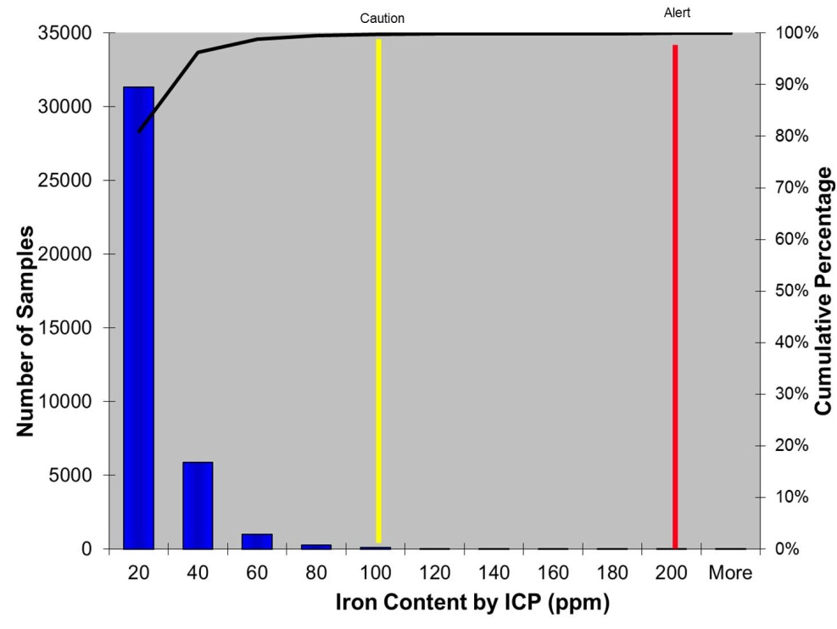
Figure 1 – Iron Content by ICP

samples and found 99.5% to be below the alert level for iron and that over 30,000 results were under 20 ppm or 10% of the limit. A look at the Figure 2 shows that of the 25,680 samples examined, iron content does not increase
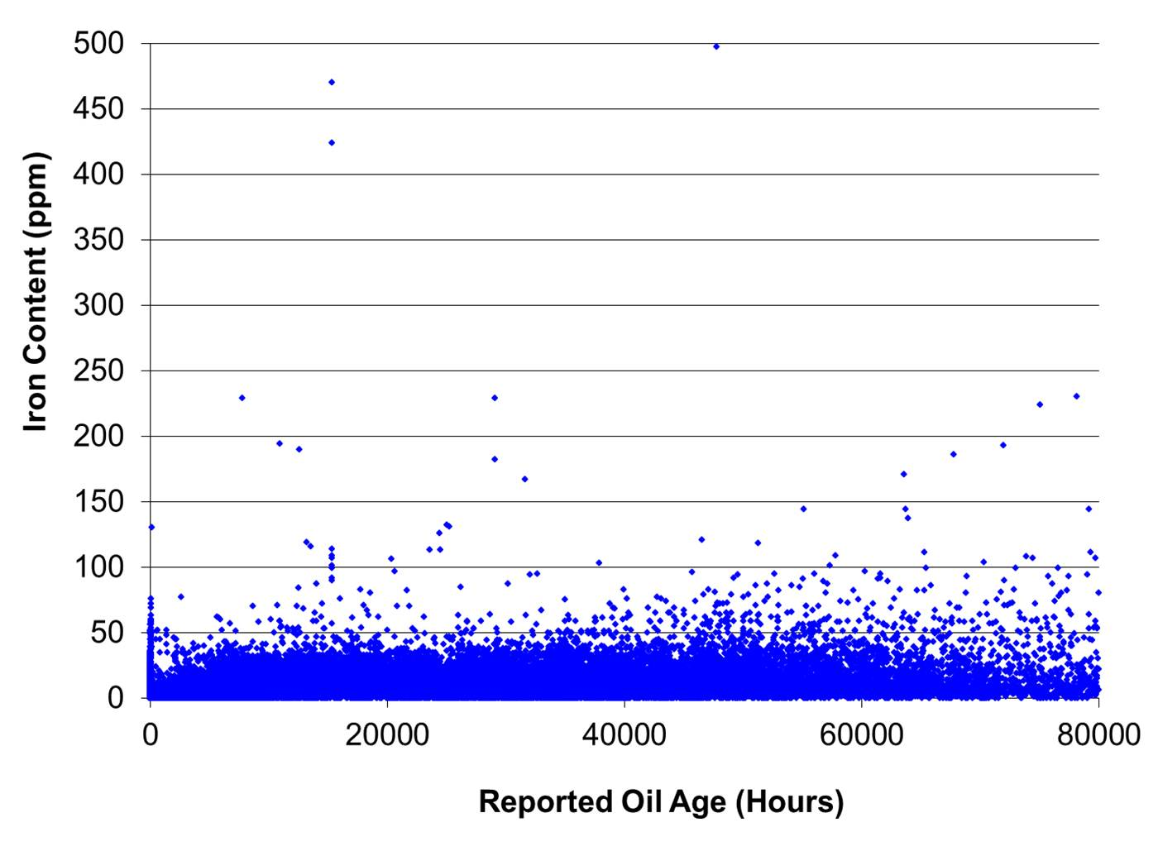
Figure 2 – Iron Content vs. Oil Age

with the used age of the oil and verifying the long term wear protection provided by the lubricant.
Oil Oxidation as Determined by Total Acid Number
The Total Acid Number (TAN) is the amount of potassium hydroxide in milligrams that is needed to neutralize the acids in one gram of oil. It is an important quality measurement of the lubricant as it reflects the oxidative state of the oil. As the TAN value of the oil increases, viscosity rises and the lubricating potential of the oil is compromised, leading to increased wear. In addition, the corrosive tendencies of the will oil increase, further exacerbating component wear. In Figure 3, ExxonMobil examined 30,778 samples and found that 99.8% of the results were

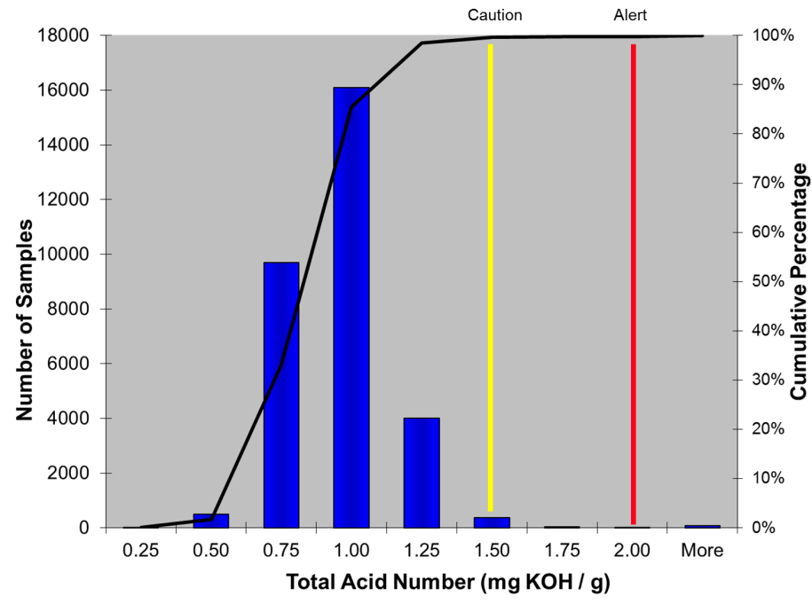
Figure 3 – Total Acid Number
below the alert levels and that 25,123 results showed little if any increase in TAN over time. This means that the
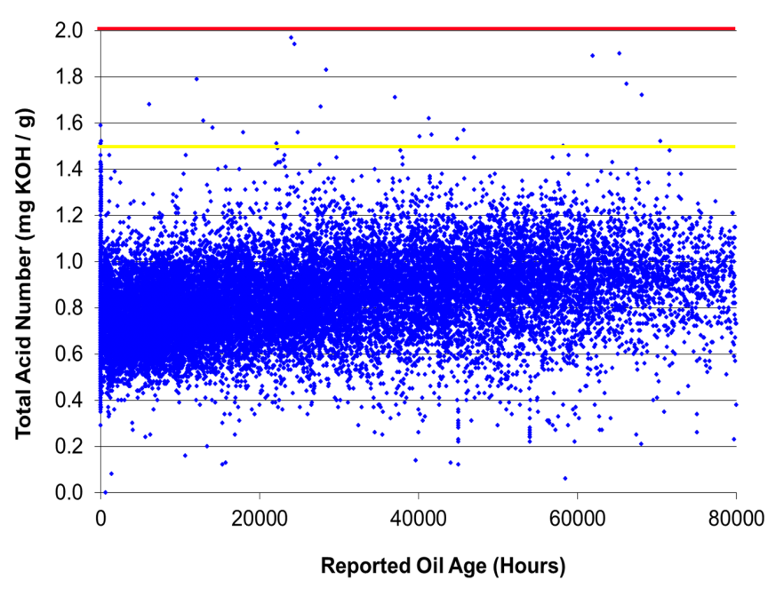
Figure 4 – Total Acid Number Over Time

life of the advanced synthetic lubricant was not impacted by turbine gearbox operation.
Viscosity Retention as an Indicator of Film Strength
Viscosity is a measure of a fluids resistance to flow and most used oil analysis laboratories report it as kinematic viscosity in centistokes (cSt) at either 40°C or 100°C. ExxonMobil examined over 38,600 data points and found that
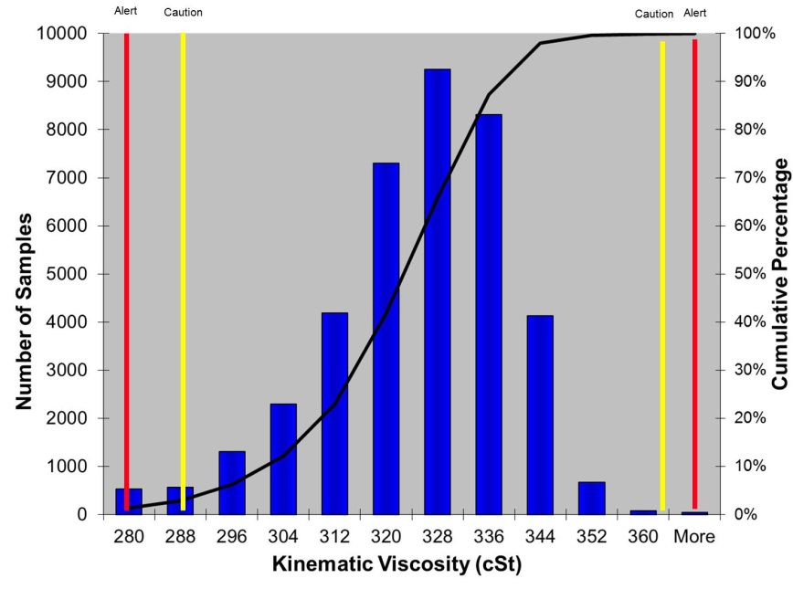
Figure 5 – Kinematic Viscosity

96% of the readings (Figure 5) were within viscosity range for fluid used. Further, a more focused look at 25,674 samples (Figure 6) found that there was no oxidative thickening or shear over time suggesting the lubricant stayed
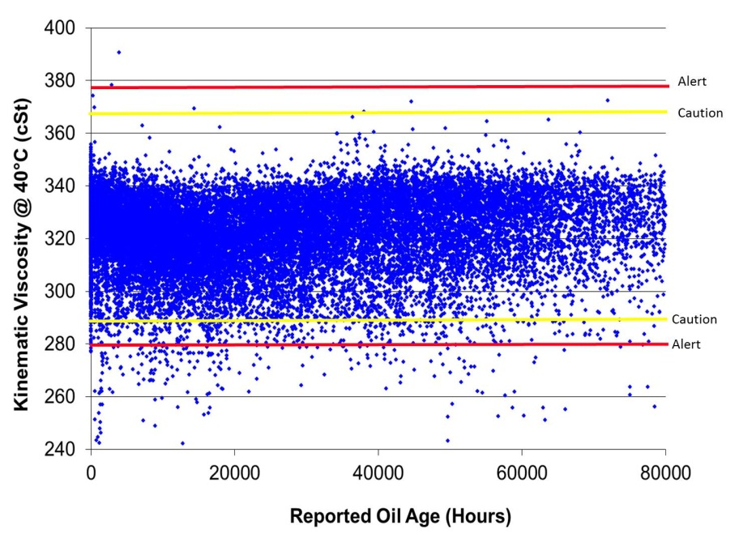
Figure 6 – Kinematic Viscosity Over Time
in viscosity grade throughout the reported service. This is an important as it confirms that the oil is able to maintain film strength providing excellent wear protection throughout its service life.
In-Service Water Levels and Wear Potential
Water as a contaminant is most relevant as its presence may cause additive depletion, viscosity drop, accelerated wear of components by hydrogen embrittlement and parts corrosion. Hydrogen embrittlement is the process by which various metals, including high-strength steel, becomes brittle and fractures following exposure
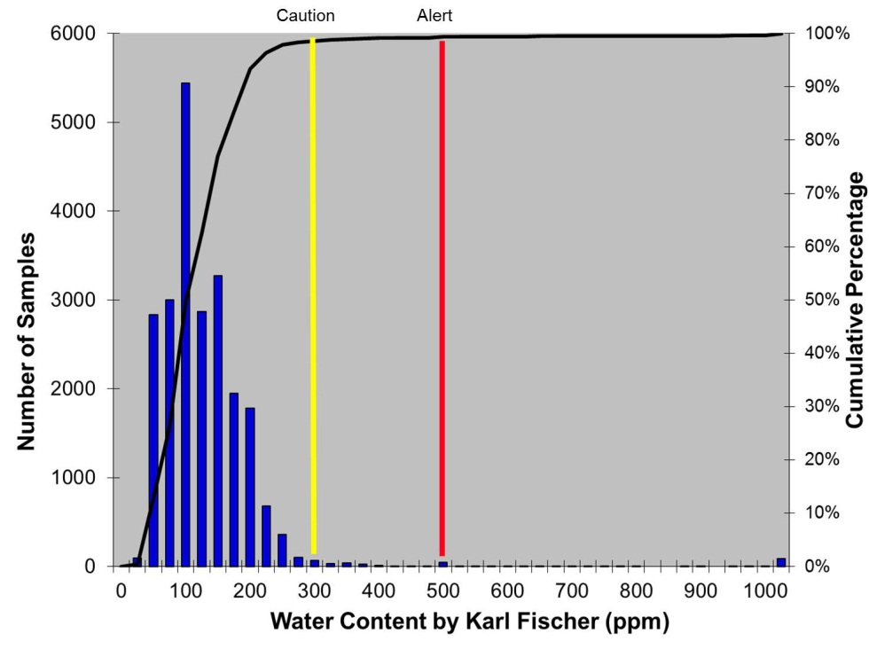
Figure 7 – Water Concentration by Karl Fischer

to hydrogen. Figure 7 shows the water content by Karl Fischer, in a just over 22,000 samples and figure 8 shows
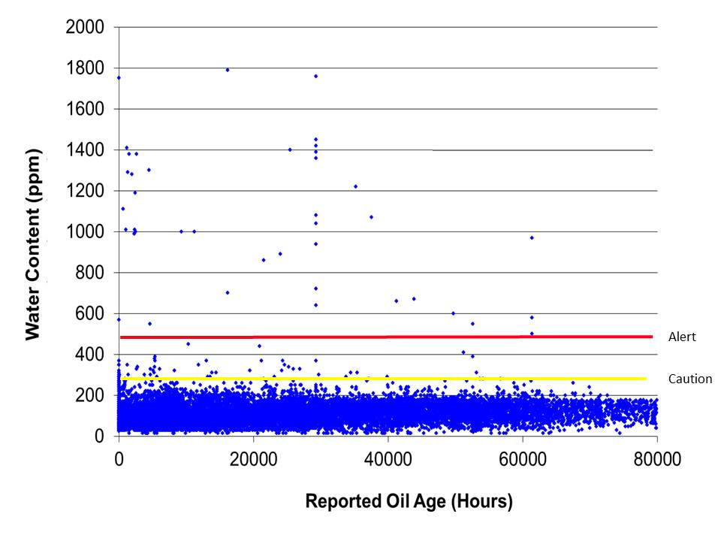
Figure 8 – Water Concentration Over Time
the water concentration in the oil over time. They find exceedingly low levels of water in the oil and that the levels present did not facilitate wear, suggesting that the lubricants lends itself to prolonged service performance.
Mobilgear SHC XMP 320 with Five Years’ Service
As a follow-up to this study, ExxonMobil examined the performance of Mobilgear SHC XMP 320 in 74 wind turbines where the oil is known to have over 5 years’ service life. This step was taken to confirm the findings of the general
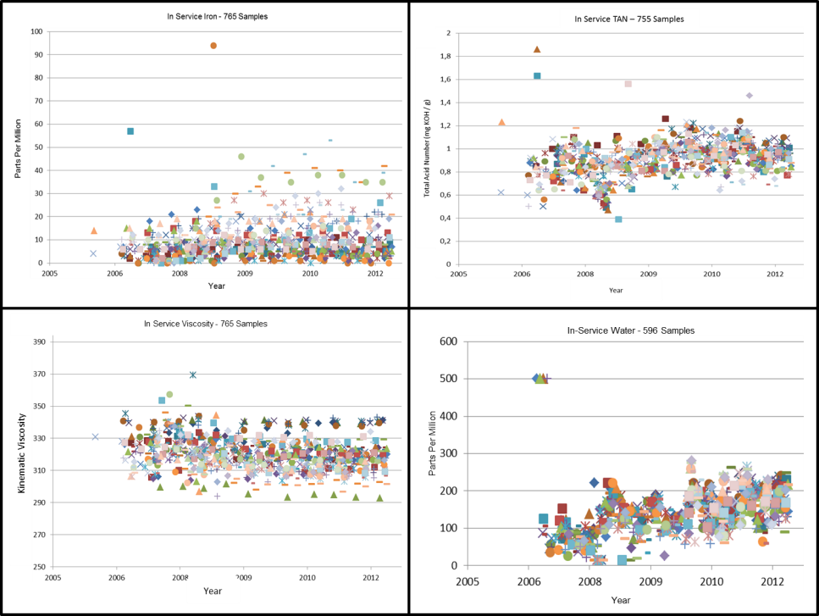
Figure 9 – 74 Wind Turbine Study

data analyzed thus far. As shown in Figure 9, this data subset mimics the findings of the much larger study with component wear minimal, oxidation by TAN insignificant, in-service oil viscosity maintained and levels of water in the oil low and non-impactful.
Conclusion
The use of Mobilgear SHC XMP 320 in the wind turbine main gearbox allows for the following features and benefits:
- Reduced Levels of Component Wear – Longer gearbox life
- Insignificant Rates of Oil Oxidation – Extended lubricant life
- Retention of Oil Viscosity – Longer gearbox and lubricant life
- Maintenance of Low Level Water Contamination – Longer gearbox and lubricant life.
Why is this important? The cost to generate wind energy is well above that of fossil fuel; 4.5¢ per kWh for coal versus for 7.5¢ per kWh for wind. For wind energy to be sustainable, it is important to control all aspects of the energy generation rate. Clearly through this study, two practices which can be improved are oil longevity and gearbox life.
In wind turbines, extending oil drain intervals means reducing oil maintenance and extending the length of time the lubricant is in service. When originally designed, the oil in a wind turbine main gearbox had an expected service life of 18 months. Today, that projection has increased 3 to 5 years and Mobilgear SHC XMP 320 has shown that five continuous years of lubricant service can be reality. What does this mean? Over the expected 20 year life cycle of a single wind turbine, the user who increases gearbox oil life from 3 to 5 years, will save approximately $15,000 per turbine. In more meaningful terms, the operator of an 80 MW wind farm with 40 - 2 MW turbines, will save $600,000 over the life cycle of the wind farm.
The cost of a utility scale wind turbine is about $1.75 million per MW of capacity with replacement of the main wind turbine gearbox approximately 10% of the overall wind turbine costs. For a 2 MW wind turbine, replacing the gear reducer would run over $500,000. Over the 20 years expected life of a wind turbine the main gearbox is expected to be replaced 2.2 times. If through the use of synthetic gear oil, gearbox life can be extended one year, the replacement costs associated with the wind turbine life cycle will be reduced by $77,000. Again, apply this savings to an 80 MW wind turbine farm with 40 - 2 MW turbines, a savings of $3.08 million will be achieved over the life cycle of the wind farm.
ExxonMobil recognizes the need to help wind energy become more sustainable. Mobilgear SHC XMP 320, as a wind turbine main gearbox lubricant does just that, bringing to reality the advantages of longer oil and equipment life, reducing the costs to produce wind energy, making it more sustainable.

